Assignment: 1
Course Name: Computer Organization & Architecture
Course Code: CSE – 203

Date of Assign: October 08, 2012
Date of Submission: October 10, 2012

-Submitted to-
Dr. Nasim Mahmud
Assistant Professor
Dept of Computer Science & Engineering
University of Liberal Arts Bangladesh

-Submitted by-
Abdullah Al Imran [ID No. 103014013]
Tasnuva Sultana [ID No. 112014017]
Sinthia Hamid [ID No. 103014022]
Fahad Zaman [ID No. 103014034]

Dept. of Computer Science & Engineering
University of Liberal Arts Bangladesh
Dhanmondi, Dhaka-1207
Question No 1. What is computer organization?
Answer: Computer Organization refers to the level of abstraction above the digital logic level, but below the operating system level.
Five major subsystems:
- Memory
- Input
- Output
- Arithmetic-logic unit (ALU)
- Control unit
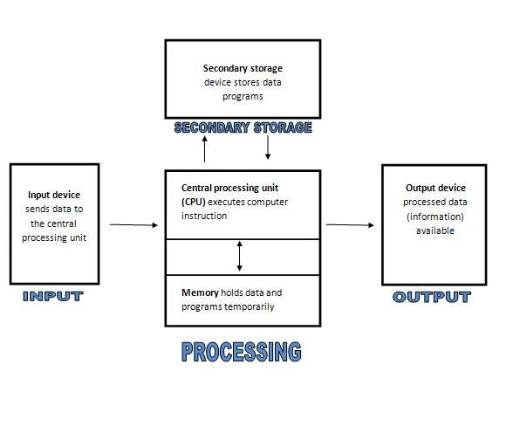
Picture: Diagram of computer architecture.
Note: the ALU and control unit together are usually referred to as the central (CPU) or simply, the processor.
Computer organization also helps plan the selection of a processor for a particular project. Multimedia projects may need very rapid data access, while supervisory software may need fast interrupts. Sometimes certain tasks need additional components as well. For example, a computer capable of virtualization needs virtual memory hardware so that the memory of different simulated computers can be kept separated. Computer organization and features also affect power consumption and processor cost.

Question No 2. What is architecture?
Answer: In computer science and engineering, computer architecture refers to specification of the relationship between different hardware components of a computer system. It may also refer to the practical art of defining the structure and relationship of the subcomponents of a computer. As in the architecture of buildings, computer architecture can comprise many levels of information. The highest level of the definition conveys the concepts implement. Whereas in building architecture this over-view is normally visual, computer architecture is primarily logical, positing a conceptual system that serves a particular purpose. In both instances (building and computer), many levels of detail are required to completely specify a given implementation, and some of these details are often implied as common practice.

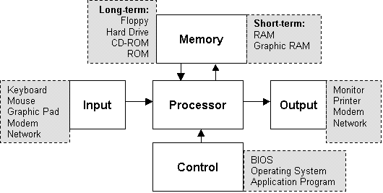
Picture: A single processor computer architecture.

For example, at a high level, computer architecture is concerned with how the central processing unit (CPU) acts and how it accesses computer memory. Some currently (2011) fashionable computer architectures include cluster computing and Non-Uniform Memory Access.

Question No 3. What are the benefits of studying computer organization and compute architecture?
Answer:
- Computer architecture is concerned with all aspects of the design and organization of the central processing unit and the integration of the CPU into the computer system itself.
- It is impossible to design an operating system well without knowledge of the underlying architecture.
- To explain how an instruction is fetched from memory and executed.
- To articulate the strengths and weaknesses of the architecture.
- Able to explain the relationship between the representations of machine level.
- We can know operation at the binary level and their representation by a symbolic assembler.
E.g. Computer organization helps optimize performance-based products. For example, software engineers need to know the processing ability of processors. They may need to optimize software in order to gain the most performance at the least expense. This can require quite detailed analysis of the computer organization. For example, in a multimedia decoder, the designers might need to arrange for most data to be processed in the fastest data path and the various components are assumed to be in place and task is to investigate the organizational structure to verify the computer parts operates.

Question No 4. What are the factors involve that prohibits us from spreading up?
Answer: Can be mentioned two reasons. Firstly not every computer parts are designed and manufactured by single manufacturer. But what is the problem about it?
The problem is if every parts of the comp do not have same bus speed the overall speed of the computer will not increase even though you may have high speed processor or others.

Other reason is the limitation of technology. You may say in recent year u want to see more speed in your computer?
Why not, we all will encourage it. But it’s getting complicated every time scientist and researchers are designing and implementing high speed computer.
To maximize the speed the CPU, Motherboard thus Integrated Circuit board are getting smaller day by day and it’s also getting complex day by day.

